**+250WAREHOUSE MANAGEMENT INFORMATION SYSTEM**

**CASE STUDY: +250WAREHOUSE**

**KABAGAMBE ISHEMA FABRICE**

**BBICT/2021/78153**

**This project is submitted in Partial Fulfillment of Requirement for Mount Kenya University Award of Bachelor of Business Information Communication and Technology.**

**SEPTEMBER 2023**

# DECLARATION

I hereby declare that this project report is based on my original work except for citations and quotations which have been duly acknowledged. I also declare that it has not been previously and concurrently submitted for any other degree or award at Mount Kenya University.

**Name:** **KABAGAMBE ISHEMA FABRICE**

Sign: __________________ Date: ………/………/2023

**SUPERVISOR**

I, the undersigned do hereby certify that this is a true report for the project undertaken by the above-named student under my supervision and that has been submitted to Mount Kenya University with my approval.

**Name**: Dr. Douglas NYABUGA

Sign ____________________ Date……. /……. /2023

**DEDICATE**

To Almighty GOD,

To our family;

To our friends;

To all our classmates and Mount Kenya University Lecturers;

To our teachers from previous years.

# AKNOWLEDGEMENTS

I would like to express my sincere gratitude and appreciation to all those who directly or indirectly contributed to a successful completion of this research proposal. First of all, I thank the almighty God for his love. He enabled me with this protection that permitted me to complete this work. My special thanks to my classmates and Mount Kenya University staff, especially lecturers of the faculty of Business Information Communication and Technology for the knowledge and skills they provided us. More importantly, I would like to express my special thanks to my supervisor Mrs. Nadia Iradukunda, for her sacrifice, continued support through our study, and the preparation of this research report. I will never forget her kindness, and humanity. I would like to thank my family in general for their help and my friends who supported me in one way or another by encouraging me, with their moral support, financial support and prayers, just to mention a few.

I am deeply grateful to my beloved classmates of Business Information Communication and Technology department, full time program, who accepted to share their ideas, knowledge and experience with me to improve this research project; I can’t forget their team work spirit.

**TABLE OF CONTENT**

DECLARATION ii

AKNOWLEDGEMENTS iv

LIST OF ACRONYMS AND ABREVIATIONS xi

LIST OF FIGURES x

LIST OF TABLE xi

CHAPTER ONE: INTRODUCTION 1

1.0 Introduction 1

1.1 Background study 1

1.2 Problem statement 1

1.3 Objective 2

1.3.1 General objective 2

1.3.2 Specific objective 2

1.4 Scope of the study 2

1.5 Project Justification 2

1.6 Project risk and mitigation 3

1.7 Project Budget and resources 3

1.8 Project schedule 4

CHAPTER TWO: LITERATURE REVIEW 5

2.1 Introduction 5

2.2 Definition of keys terms 5

2.2.1 Gas Agency 5

2.2.2 Embedded System 5

2.2.3 Information System 5

2.2.4 System 6

2.2.5 Database Management System 6

2.2.6 MySQL 6

2.2.7 PhpMyAdmin 6

2.2.8 Management Information System (MIS) 7

2.2.9 User 7

2.2.10 Website 7

CHAPTER THREE: METHODOLOGY 8

3.0 Introduction 8

3.1 Data collection and procedures 8

3.2 Primary data 8

3.2.1 Observation 8

3.2.2 Interview 9

3.3 Secondary data 9

3.4 Software development life cycle 9

3.4.1 Waterfall model 9

3.4.1.1 System engineering 10

3.4.1.2 Requirements and Analysis 10

3.4.1.3 Design 11

3.4.1.4 Implementation 11

3.4.1.5 Testing 11

3.4.1.6 Maintenance 11

3.5 Software/ hardware technologies 11

3.5.1 Software 11

3.5.2 Hardware 12

CHAPTER FOUR: SYSTEM ANALYSIS AND REQUIREMENT MODELING 13

4.0 Introduction 13

4.1 Context Diagram 13

4.2 Data flow diagram 13

4.2.1 View Dashboard 15

4.2.2 Input Details 15

4.2.3 Process Information 15

4.2.4 Information Storage 15

4.2.5 Dashboard 15

4.2.6 Output 16

4.2.7 Retrieve Information 16

4.2.8 Generate Report 16

4.3 Admin Case Diagram 16

4.3.1 Admin Case 17

CHAPTER FIVE: SYSTEM DESIGN 20

5.0 Introduction 20

5.1 Interface design 20

5.1.1 Project Interfaces 20

5.2 Database Design 22

5.2.1 Entity relation Diagram 22

CHAPTER SIX: SYSTEM IMPLEMENTATION AND TESTING 23

6.0 Introduction 23

6.1 Software Technologies 23

6.1.1 Php 23

6.1.2 HTML 24

6.1.3 CSS 24

6.1.4 MySQL 24

6.1.5 Bootstrap 24

6.2 System Testing 25

6.2.1 Objective of the Testing 25

6.2.2 Testing plan 26

6.2.3 Unit Testing 26

6.2.4 Validation Testing 26

6.2.5 Integration Testing 26

6.2.6 Function and System Testing 27

6.2.7 Acceptance Testing 27

6.2.8 White box testing 27

CHAPTER SEVEN: LIMITATION, RECOMMENDATION AND CONCLUSION 28

7.0 Introduction 28

7.1 Limitation 28

7.2 Conclusion 28

7.3 Recommendation 28

REFERENCES 30

APPENDICES 31

# LIST OF FIGURES

Figure 3. 1: Waterfall Method 10

Figure 4. 1:Context Diagram……………………………………………………………………..13

Figure 4. 2: DFD 14

Figure 4. 3: Admin Use Case 17

Figure 4. 4: Manager Case 18

Figure 4. 5: Supplier Case 18

Figure 4. 6: Activity Diagram 19

Figure 5. 1:Dashboard……………………………………………………………………………20

Figure 5. 2: Login Page 21

Figure 5. 3: Report Page 21

Figure 5. 4:ERD 22

# LIST OF TABLE

Table 1. 1: Project Resources 3

Table 1. 2: Project Schedule 4

# LIST OF ACRONYMS AND ABREVIATIONS

**ADMIN:** Administrator

**CSS:** Cascading Style Sheet

**DFD:** Data Flow Diagram

**ERD**: Entity relationship Diagram

**HTML:** Hypertext Markup Language

**ICT:** Information and Communication Technology

**IT:** Information Technology

**MYSQL:** My Structure Query Language

**PHP:** Hypertext Pre-Processor

**WWW:** World Wide Web

# CHAPTER ONE: INTRODUCTION

## **1.0 Introduction**

## The +250 warehouse Management Information System is a comprehensive solution designed to help to manage their product selling operations with ease. The system provides tools for tracking stock levels, bookings, and other aspects of product’s management. With this system, +250 warehouse will be able to streamline their stores management and ensure smooth operations.

## **1.1 Background of The Study**

+250warehouse is a product distribution company founded in 2019 and it is directly affiliated with BRALIRWA, which means that the products that are distributed in +250 stores from the warehouse are only BRALIRWA products and its focuses include distributing goods such as for beers like: Primus, Turbo King, Mutzig, Heineken, Amstel. And for soft drinks like: Coca-Cola, Coca-Cola zero, Fanta (orange, citron, fiesta and pineapple), Sprighte, Soda water( Vitalo sparking water) and Cheetah energy drink and in addition we have Legend. +250 warehouse commercial markets has a portfolio of 260 stores located throughout Kigali.

## **1.2 Problem Statement**

+250 warehouse currently face several challenges in managing their goods selling, including inefficient stock tracking, manual record-keeping, and a lack of real-time insights into sales and stock levels. These issues result in increased operational costs, decreased productivity, and potential loss of business due to stockouts, inventory accuracy, technology integration, supply chain complexity and seasonal demand variation. Warehouse Management Information System aims to address these challenges by providing a centralized, automated solution for tracking stock, sales, and other aspects of good’s management, improving operational efficiency, and enabling better decision-making.

## **1.3 Objective**

### **1.3.1 General Objective**

To develop an online Warehouse Management Information System

### **1.3.2 Specific Objective**

1. To implement user interface to allow user to interact with the system.
2. To implement a database to record +250 warehouse
3. To develop a system that will provide data analytics and reporting capabilities.

## **1.4 Scope of the Study**

The study will focus on designing and implementing a Warehouse Management Information System for all +250 warehouse stores selling agency. The scope includes analyzing current business processes, identifying key system requirements, developing the system architecture, and implementing the software. The study will cover areas such as gas stock management, sales data tracking, customer information management, and reporting. The system will be designed to be user-friendly and scalable, accommodating future business growth. Finally, the study will provide recommendations for ongoing maintenance and system upgrades to ensure continued effectiveness and efficiency.

## **Project Justification**

The implementation of warehouse Management Information System will address several challenges faced by +250 warehouse selling agency, including inefficient stock tracking, manual record-keeping, and a lack of real-time insights into sales and stock levels. The system will provide a centralized, automated solution that streamlines Warehouse management, reduces operational costs, and minimizes the risk of stockouts. The system will also enable +250 warehouse to gain valuable insights into sales patterns, customer behavior, and other key performance indicators, which can inform future business decisions. Overall, Warehouse Management Information System is a necessary investment for +250 warehouse continued success and growth in the competitive product selling market.

## **Project Risk and Mitigation**

The developer is expecting that the system would unfortunately be compromised through malicious activities and the other risks which can cause the system can to crash , and attacked by virus. As for mitigating the control that will be put in place is a strong anti-virus and system back up and investment in encryptions of online transactions.

## **Project Budget and Resources**

**Table 1. 1:Project Resources**

|  |  |  |
| --- | --- | --- |
| **Item** | **Quantity** | **Price (Rwf)** |
| Laptop | 1 | 350,000 |
| Network  External hard drive(1TB) | -  1 | 25,000  50,000 |
| Printing | - | 10,000 |
| Application software’s and Antivirus | - | 30,000 |
| Communication & Transport | - | 20,000 |
| Miscellaneous cost | - | 40,000 |
| Total |  | **525,000** |

## **Project schedule**

The table below shows a brief description of the project activities through different chapters against the time schedule as a Gantt structure.

**Table 1. 2:Project Schedule**

|  |  |  |  |  |  |  |  |  |  |  |  |  |
| --- | --- | --- | --- | --- | --- | --- | --- | --- | --- | --- | --- | --- |
| Activities | June | | | | July | | | | August | | | |
| 1 | 2 | 3 | 4 | 1 | 2 | 3 | 4 | 1 | 2 | 3 | 4 |
| Project proposal |  |  |  |  |  |  |  |  |  |  |  |  |
| Chapter 1: Introduction |  |  |  |  |  |  |  |  |  |  |  |  |
| Chapter 2: Literature Review |  |  |  |  |  |  |  |  |  |  |  |  |
| Chapter 3: Methodology |  |  |  |  |  |  |  |  |  |  |  |  |
| Chapter 4: Requirements analysis and Modeling |  |  |  |  |  |  |  |  |  |  |  |  |
| Chapter 5: System Design |  |  |  |  |  |  |  |  |  |  |  |  |
| Chapter 6: System Implementation. |  |  |  |  |  |  |  |  |  |  |  |  |
| Chapter 7: Recommendation& conclusions |  |  |  |  |  |  |  |  |  |  |  |  |
| Final Presentation and Demos |  |  |  |  |  |  |  |  |  |  |  |  |
| Documentation |  |  |  |  |  |  |  |  |  |  |  |  |

**Table 3: Project Activities Schedule(GANTT CHART)**

# CHAPTER TWO: LITERATURE REVIEW

## **2.1 Introduction**

The main objectives of this chapter is to clarify the term that will be used in the project including the main definition, the comparison of other project in order to establish to a gap which this project intend to fill. Literature review means a collecting related data, analysis business process, identifying patterns and create the conclusion.

## **2.2 Definition of keys terms**

### **2.2.1 +250 warehouse**

+250 warehouse is a large commercial building or facility designed for the storage and distribution of goods and it serves as a central location where businesses can store their inventory before it is sold or distributed to customers.

### **2.2.2 Embedded System**

An embedded system is a computer system with a dedicated function within a large mechanical or electrical system, often with real-time computing constraints. It is embedded as part of a complete device include hardware and mechanical parts. Embedded systems control many devices in common use today. Ninety-eight of all microprocessors are manufactured as embedded systems. (Barr.2007)

### 2**.2.3 Information System**

Information system is an integrated set of components for collecting, storing, and processing data and for providing information, knowledge, and digital products. Business firms and other organizations rely on information system to carry out and manage their operations, interact with their clients and suppliers, and compete in the marketplace. Information systems are used to run inter-organization supply chains and electronic market (Joseph S.2008).

### **2.2.4 System**

System is an organized, purposeful structure that consists of interrelated and interdependent elements (components, entities, factors, members, parts etc.) These elements continually influence one another (directly or indirectly) to maintain their activity and the existence of the system, in order to achieve the goal of the system. All system has inputs, outputs and feedback mechanism; maintain an internal steady- state (called homeostasis) despite a changing external environment and have boundaries that are usually by system observer. (Kroenke,2015)

### **2.2.5 Database Management System**

A database management system is the software system that allows users to define, create and maintain a database and provides controlled access to the data. A database Management system (DBMS) is basically a collection of programs that enables users to store, modify, and extract information from a database as per the requirements. DBMS is an intermediate layer between programs and the data. Programs access the DBMS, which then access the data. There are different types of DBMS ranging from small system that run on mainframes. (Ronald,2001)

### **2.2.6 MySQL**

MySQL is freely available open source relation database management system (RDBMS) that uses structured query language (SQL). SQL is the most popular language for adding accessing and managing content in the database. MYSQL is an essential part of almost every source PHP application.

### **2.2.7 PhpMyAdmin**

PhpMyAdmin is a free software tool written in PHP intended to handle the administration of MySQL. The most frequently used operations are supported by user interface (managing databases, tables, fields, relations, indexes, users, permissions, etc.), while you still have the ability to directly execute any SQL statement. This graphical interface allows you to add, edit, and create data in a database with ease. PhpMyAdmin program is handy for performing maintenance operation on tables, backing up information, and editing things directly in the event that your script is not working. Occasionally, in the support forums, someone will post an SQL query of some benefit or other that can be run using PhpMyAdmin. Although many tasks can be performed on the MySQL command line, doing so is not an option for many people. (Ronald 2001).

### **2.2.8 Management Information System (MIS)**

Management information system (MIS) refers to complementary networks of hardware and software cooperating to collect, process, store, and disseminate information in order to support the managerial role of levering information technology to increase business and value and profit. For business MIS is a computerized database of financial information organized level management.

### **2.2.9 User**

A user is a person who utilizes a computer or network service. Users of computer systems and software products generally lack the technical expertise required to fully understand how they work. (Susan, April 2011).

### **2.2.10 Website**

A website (also written as web site) is a collection of web pages and related content that is identified by a common domain name and published on at least one web server. (Robert,2017)

# CHAPTER THREE: METHODOLOGY

## **3.0 Introduction**

This chapter explains methods which are used to collect data during research and software tools used to collect data and information for the purpose of making decision. The methodology may include publication research interview, surveys and other research techniques. This chapter also describes the system development method. A system development methodology in software engineering is a framework that is used to structure, plan as well as control the process of developing an information system.

## **3.1 Data collection and procedures**

To conduct a research, we need a data collection. Data collection is one of the most important stages in conducting a research. You can have the best research but if you cannot collect the required data you will not be able to complete the project’s objectives. There are many methods to collect data, depending on research design and methodologies employed. Some of the common methods are questionnaires, documentation, interviews and observation. In this project the following data collection techniques were used in collecting data. (Norman, 1986).

## **3.2 Primary data**

### **3.2.1 Observation**

As reported by Elke Van Observation is a process of recording the behavior of people, object and occurrences without questioning or communicating with them. Under observation method, the information is sought by way of the investigator’s own direct observation without asking from the respondent. The main advantage of this method is that the bias is eliminated, if observation is done accurately. This project used this method to collect data from +250 warehouse.

### **3.2.2 Interview**

Interviewing involves asking questions and getting answers from participants in a study. Interviewing has a variety of forms including: individual, face-to-face interviews and face-to-face group interviewing. The asking and answering of questions can be mediated by the telephone or other electronic devices (e.g. computers). Interviews can be Structured, Semi-structure or Unstructured. (Internet). This project used this method to collect data from users of the system.

## **3.3 Secondary data**

Secondary data were obtained by the researcher from magazines, journal, newspaper, library source and internet downloads. The data collected in this particular instance means they have been covered in literature review in chapter two.

## **3.4 Software development life cycle**

System development methodology is a technique that is used to show how the proposed system will be developed. In this case, the methodology used will be in waterfall model.

### **3.4.1 Waterfall model**

It consists of the stages that the developer will use when developing the system. It is a sequential, hence the name waterfall. The developer has to finish with one stage before going to the next one. It consists of the feasibility study or system engineering, analysis phase, design phase, coding phase, testing phase, implementation phase and lastly the maintenance phase. I went through different methodologies like, prototyping, spiral, etc. and I decided to use waterfall mode during the development of this project. This guided me in the implementation of my project; waterfall development methodologies have the advantages of identifying requirements before programming begins and limiting changes to the requirements as the project proceeds. Waterfall model consists of a number of development phases that are executed in sequential order. A phase only starts when the previous has been completed. The complete solution is released at the final phase.

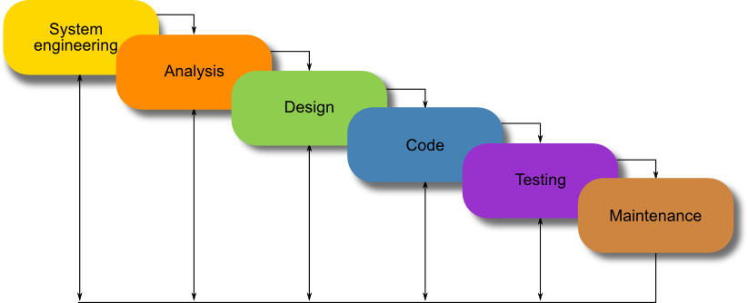

**Figure 3. 1:Waterfall Method**

#### **3.4.1.1 System engineering**

During this stage the developer carry out the study to gain an understanding of the clients (vehicle owners), current system used and the issues experienced in this system through interview with +250 warehouse Manager, observations and participations. The developer will use the obtained data to determine the viability of the system being proposed in terms of technical, economic and operation feasibility.

#### **3.4.1.2 Requirements and Analysis**

Here, the developer gathers information about what the customer needs and define the problems the system is expected to solve. The developer also includes clients, business context, products functions and its compatibility. The developer gathers requirement such as software like the programming language to use, database model and hardware needed like computer, printer etc.

#### **3.4.1.3 Design**

At this stage, the developer make an overall design other system architecture and physical design include user interface and database design. It is at this stage the developer identifies any faults before moving onto the next stage. The output of the design specification which is used in the next stage of implementation.

#### **3.4.1.4 Implementation**

At this stage, the developer begins coding as per design specifications. The output of this step is one or more product components built according to a pre-defined coding standard and debugged, tested and integrated to satisfy the system architecture requirement.

#### **3.4.1.5 Testing**

At this stage, the developer ensures both individual and integrated whole methodically verified to ensure they are error free and satisfy customer requirement. The developer involves in both unit testing of individual code module, system testing of the integrated product and acceptance testing conducted by or on behalf of customer. The developer ensure bugs found are corrected before moving to the next stage. The developer also prepares, review and publish product documentation.

#### **3.4.1.6 Maintenance**

Lastly, this stage occurs after installation. It involves modifications on the system to improve performance. Such changes are user initiated or as result of bug being discovered which were initially not known. These modifications are recorded for documentation and system update.

## **3.5 Software/ hardware technologies**

### **3.5.1 Software**

1. Font-End (HTML, CSS, JavaScript, JQuery, Ajax)
2. Back-end (PHP)
3. Database (MySQL)

### **3.5.2 Hardware**

1. RAM 16 GB
2. Hard disk 1 TB
3. System type 64 bit
4. Processor: Intel(R) Core(TM) i5-8265U CPU @ 1.60GHz 1.80 GHz.

# CHAPTER FOUR: SYSTEM ANALYSIS AND REQUIREMENT MODELING

## **4.0 Introduction**

This chapter highlights the steps to be followed in achieving the objectives of the research which are the information gathering for describing different techniques used to get information about the current used system, description of the proposed system. Admin cases shows how an admin interact with the system and activity diagram shows how admin interact with system’s interface.

### **4.1 Context Diagram**

System context diagram shows a system, often software-based, as a whole and its inputs and outputs from/to external factors. According to Kossiakoff and sweet (2011), System Context Diagrams represent all external entities that may interact with a system. Such as diagram pictures the system at the center, with no details of its interior structure, surround by all interacting systems, environments and activities.

Admin

SYSTEM

Database

Report

**Figure 4. 1:Context Diagram**

#### **4.2 Data flow diagram**

A data flow Diagram is also a graphical representation of the “flow” of data through an information system, modeling its process aspects. Often is a preliminary step used to create an overview of the system which can later be collected. DFD shows the flow of data through a system. It views system as a function that transforms the input into outputs. Any complex system will not perform this transformation in a single step, and data will typically undergo a series of transformation before the output. The DFD aims to capture the transformation that place within a system to the input data so that eventually the output data is produced. The agent that perform of data from one state to another is called a process (or bubble).

This DFD shows the movement of data through the different transformation or process in the system.

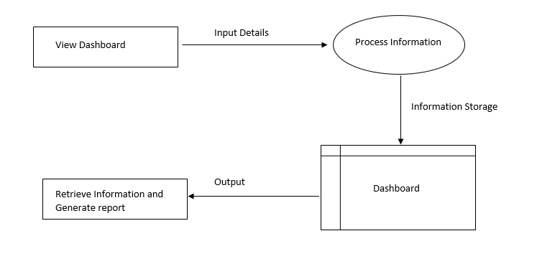

**Figure 4. 2:DFD**

### **4.2.1 View Dashboard**

Represents all the components included in the system like the home page which provides an overview of the system's metrics, and features like bookings, suppliers, configurations. It is a graphical user interface or visual representation of the system's data and insights. It is the interface through which users interact with the system, view the generated reports, and access relevant information.

### **4.2.2 Input Details**

This represents the process of capturing or collecting information. It involves gathering relevant data elements required for the system's operation, such as make a booking, entering new to the system.

### **4.2.3 Process Information**

This feature represents the processing or manipulation of the collected data. It involves applying various operations, calculations, transformations to the input data in order to derive meaningful insights, perform analysis, or generate desired outputs.

### **4.2.4 Information Storage**

This feature denotes the storage or persistence of data within the system. It involves saving the processed information or any other relevant data in a database. This data can be accessed or retrieved later as needed.

### **4.2.5 Dashboard**

This allows system user to access and visualize the dashboard, which presents relevant information and insights in a user-friendly format. It provides an overview of the system's data and helps users monitor key metrics or performance indicators.

### **4.2.6 Output**

This feature represents the display or presentation of information from the system’s database to the end-users. It involves generating reports, displaying visualizations, or providing any other output format that conveys the processed information in a meaningful way.

### **4.2.7 Retrieve Information**

Represents the process of fetching or accessing stored data from the database. It allows the system to retrieve specific information as requested by end-user of the system.

### **4.2.8 Generate Report**

Involves creating structured or formatted reports based on the processed information. It takes the relevant data and presents it in a well-organized manner, and summarized manner, which can be easily interpreted by the users.

## **4.3 Admin Case Diagram**

Admin Case Diagram is a visual representation of the interaction between an admin and the system, depicting the specification of admin cases. It helps in understanding how admins interact with the system and perform specific administrative tasks.

**Actor:** Admin, Operator, People involved in the System.

**Admin case:** Activity, Action, and Process.

### **4.3.1 Admin Case**

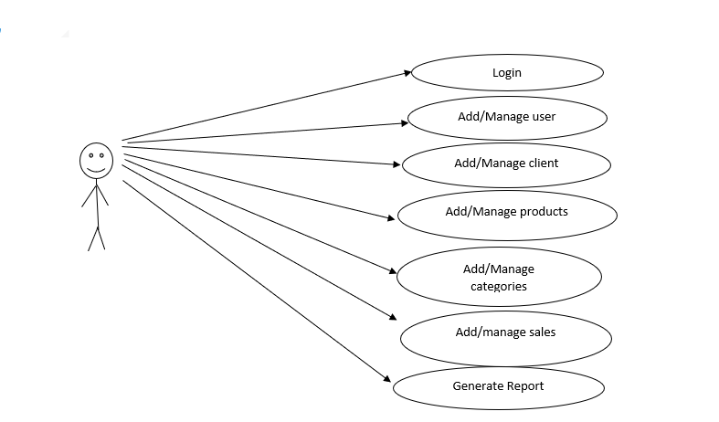

**Figure 4. 3:Admin Use Case**

**4.3.2 Manager Case**

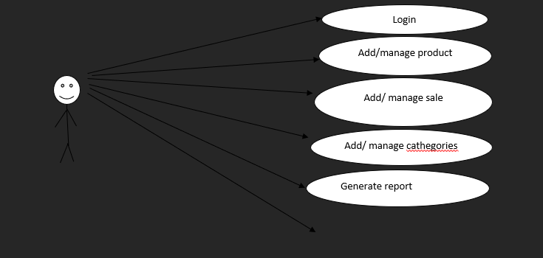

**Figure 4. 4:Manager Case**

**4.3.3 Cashier Case**

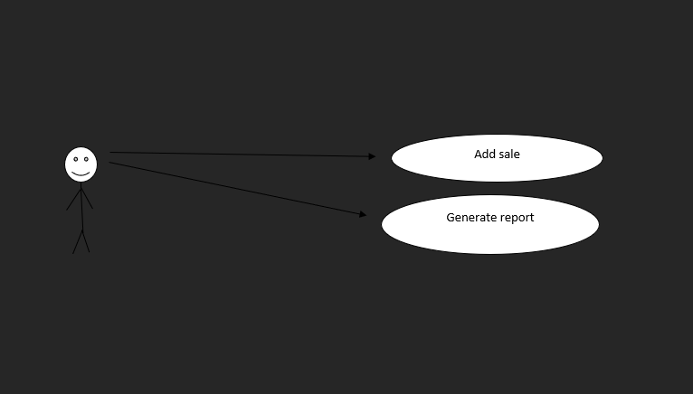

**Figure 4. 5:Supplier Case**

##### **4.4 Activity Diagram of the System**

The activity diagram is used primarily to show the interactions between objects in the sequential order where those interactions occur. Much like the class diagram, developers especially think sequence diagram were meant exclusively for them. Basic Activity Diagram Notation and Symbols initial state or Start Point.

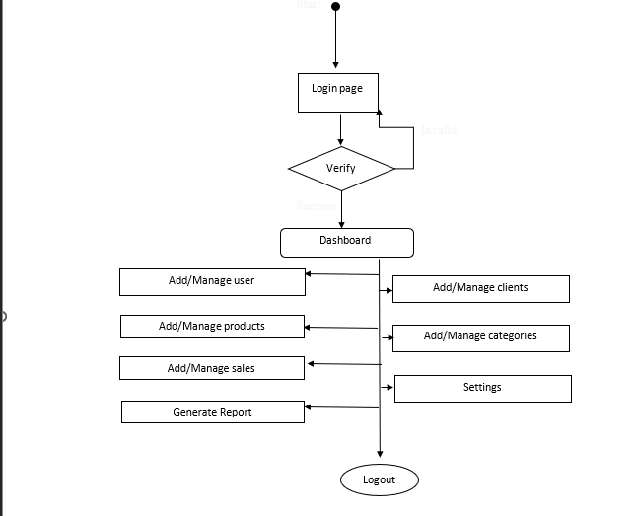

**Figure 4. 6:Activity Diagram**

# CHAPTER FIVE: SYSTEM DESIGN

## **5.0 Introduction**

System design is the process of defining the architecture modules interfaces and data for a system to satisfy specified requirement. This chapter, we explain the new system with new concept of how the application has been conceived and also we will try to explain technologies applied to build. This chapter contains tools used for the development of this system and means of test used in order to be sure with the accuracy of its performance. System design is the process of defining the architecture modules interfaces and data for a system to satisfy specified requirement.

## **5.1 Interface design**

Interface design is the design of user interfaces for machines and software, such as computers, home appliances, mobile devices, with the focus on maximizing usability and the user experience. These interfaces provide facilities such as user friendly graphics so that the users can fell fair with the system and accomplish their work without any harm.

### **5.1.1 Project Interfaces**

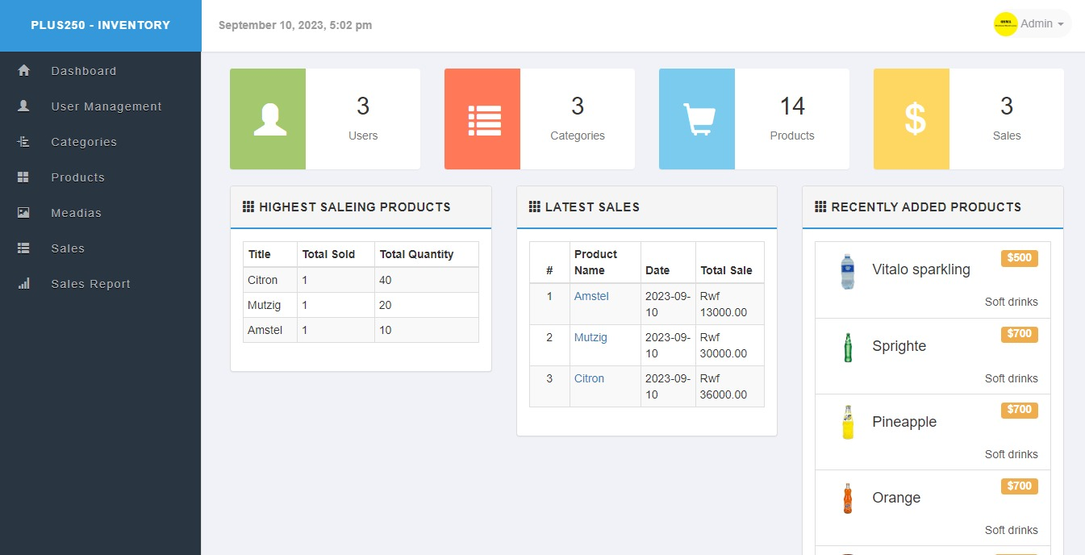

**Figure 5. 1:Dashboard**

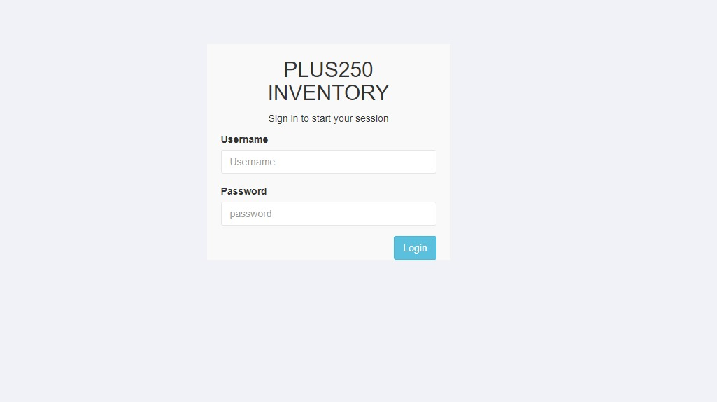

**Figure 5. 2:Login Page**

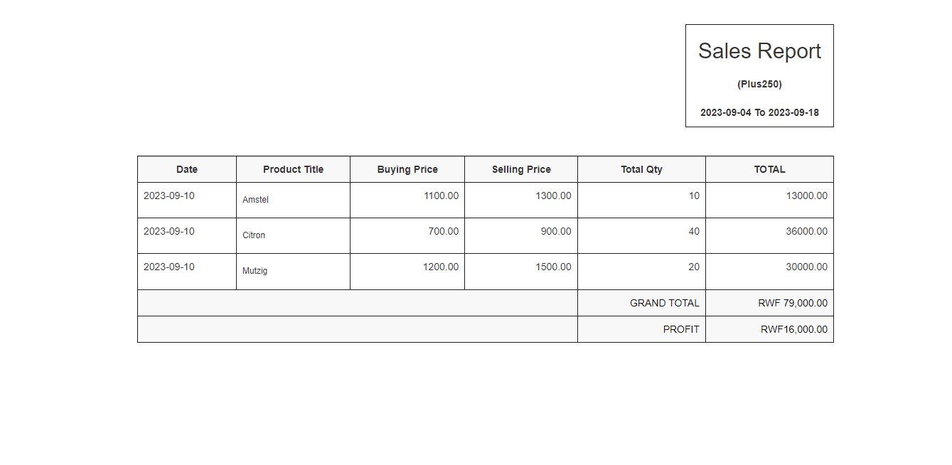

**Figure 5. 3:Report Page**

## **5.2 Database Design**

A database is a collection of related data; database design is the organization of data according to database model.

### **5.2.1 Entity relation Diagram**

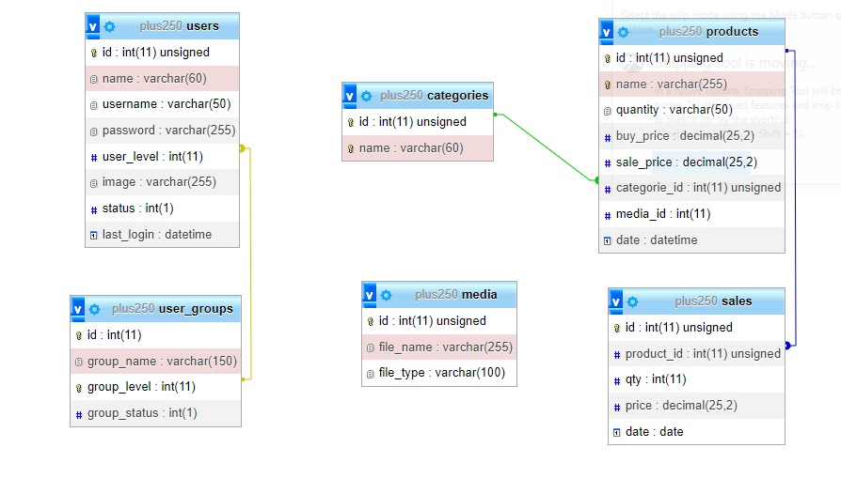

**Figure 5. 4:ERD**

# CHAPTER SIX: SYSTEM IMPLEMENTATION AND TESTING

## **6.0 Introduction**

Implementation is the process that actually yields the lowest-level systems in the system hierarchy (system breakdown structure). System elements are made, bought, or reused. Production involves the hardware fabrication process of forming, removing, joining, and finishing, the software realization process of coding and testing, or the operation procedures for operator’s roles. If implementation involves a production process, a manufacturing system which uses the established technical and create (or fabricate) a system element conforming to that element’s design properties and or requirements. The element is constructed employing appropriate technologies and industry practices.

## **6.1 Software Technologies**

Programming tool or software development tool is a computer program that software developers use to create, debug, maintain, or otherwise support other programs and applications. The term usually refers to relatively simple programs, that can be combined together to accomplish a task, much as one might use multiple hand tools to fix a physical object. The ability to use a variety of tools productively is one hallmark of a skilled software engineer. The most basic tools are a source code editor and a compiler or interpreter, which are used ubiquitously and continuously. Other tools are used more or less depending on the language, development methodology, and individual engineer, and are often used for a discrete task, like a debugger or profiler.

### **6.1.1 Php**

PHP: Hypertext Pre-Processor a server-side scripting language designed for web development but also as a general-purpose programming language. PHP is very easy for beginners and also offers many advanced features for professional programmers. PHP runs efficiently on Apache server, but it can also run on IIS. PHP is an open-source and cross-platform language. It can be built as an apache module or a CGI script. As an Apache module, PHP is very and lightweight, allowing for quick turnaround.

### **6.1.2 HTML**

HTML (Hyper Text Mark-up Language) is the set of mark-up symbols or codes inserted in a file intended for display on a World Wide Web browser page. The mark-up tells the web browser how to display a web page’s words and images for the user. Each individual mark-up code is referred to as an element (but many people also refer to it as a tag). Some elements come in pairs that indicate when some display effect is to begin and when it is to end.

### **6.1.3 CSS**

Cascading Style sheet is a kind of programming language that can be used to set the styles and qualities of different website component and pieces of content, it can be used to set universe color, text and background properties for certain columns, tables, layers and the entire website body.

### **6.1.4 MySQL**

MySQL is freely available open source relation database management system (RDBMS) that uses structured query language (SQL). SQL is the most popular language for adding accessing and managing content in the database. MYSQL is an essential part of almost every source PHP application.

### **6.1.5 Bootstrap**

Bootstrap is free and open-source front-end web framework for designing websites and web applications. It contains HTML and CSS-based design templates for typography, forms, buttons, and navigation and other interface components, as well as optional JavaScript extensions. Unlike many web frameworks, it concerns itself with front-end development only.

## **6.2 System Testing**

System testing is the testing of a complete and fully integrated software product. Usually software is only one element of a larger computer based system. Ultimately, software is interfaced with other software/hardware systems.

System testing is actually a series of different tests whose sole purpose is to exercise the full computerbased system. System testing falls under the black box testing category of software testing. White box testing is the testing of the internal workings or code of a software application. In contrast, black box or system testing is the opposite.

### **6.2.1 Objective of the Testing**

Software testing is an investigation conducted to provide stakeholders with information about the quality of the product or service under test. Software testing can also provide an objective, independent viewof the software to allow the business to appreciate and understand the risks of software implementation. It is the process of executing a program or application with the intent of finding software bugs (errors or other defects). Testing should systematically uncover different classes of errors in a minimum amount of time and with a minimum amount of effort. A secondary benefit of testing is that it demonstrates that the software appears to be working as stated in the specifications. The data collected through testing can also provide an indication of the software’s reliability and quality. But testing cannot show the absence of defect it can only show that softwaredefects are present.

### **6.2.2 Testing plan**

A test plan is a document detailing a systematic approach to testing a system such as a machine or software. The plan typically contains a detailed understanding of the eventual workflow. A test plan documents the strategy that be used to verify and ensure that a product or system meets its design specifications and other requirements. A test plan is usually prepared by or with signification input from test engineers.

### **6.2.3 Unit Testing**

Unit testing is a testing done at the individual level of program or module. Sometimes, it refers to module testing. The purpose of unit testing is to identity and reduce execution errors that cause the program to terminate abnormally, and logic errors that could have been missed during desk checking.

### **6.2.4 Validation Testing**

System Validation is a set of action used to check the compliance of any element (a system element, a document, a service, a task, a system requirement, etc.) With its purpose and functions. These actions are plannedand carried out throughout the life cycle of the system. Validation is a genetic term that needs to be instantiated within the context it occurs. Validation determine if the system compiles with the requirements and performs function for which it is intended and meet the user need and the organization’s goals.

### **6.2.5 Integration Testing**

Integration testing (Sometimes called integration and testing, abbreviated I&T) is the phase in softwaretesting in which individual software modules are combined and tested as a group. It occurs after unit testing and before validation testing. Integration testing is a testingwhere it involves two or more modules that link each other. It’s a process of bringing together all the modules that a program comprises for testing purposes.

### **6.2.6 Function and System Testing**

After completing the integration testing, we must perform system testing, which involves the entire system. It’s similar with an integration testing. The different is in system testing, we integrate programs into system. After the system testing is completed. We can assume that the system is fully tested are free any errors or bugs so now it’s ready to be installed and hosted.

### **6.2.7 Acceptance Testing**

Here, the tester hat to literally like the client and test software with respect to user needs, requirement, and business process, and determine whether the software can be handed over to the client or not. At this stage**,** often, a client represent is also a part of testing, so that the client has confidence in the system.

### **6.2.8 White box testing**

 White Box Testing (WBT) is also known as Code-Based Testing or Structural Testing, it is a testing technique that examines the program structure and derives test data from the program logic or code by analyzing the internal structure of the system. White box testing involves the testing by looking at the internal structure of the code. When you complete aware of the internal structure of the code. When you can run your test cases to check whether the system meet requirement mentioned in the specification document. Based on derived test cases the user exercised the sets cases by giving the input to the system and checking for expected outputs with actual output. In this testing method user has to go beyond the user interface to find the correctness of the system.

# CHAPTER SEVEN: LIMITATION, RECOMMENDATION AND CONCLUSION

## **7.0 Introduction**

This chapter reflects back on the objectives of the system development and putting into consideration the possible challenges, limitations, recommendation and conclusions.

## **7.1 Limitation**

One of the project limitations is the system's internal usage only, exclusively for the owners of the warehouse. External users, including customers and suppliers, are unable to directly access or utilize the system. The system still uses manual payment via mobile money but in the future, we are planning on payment will be paid online using the system.

## **7.2 Conclusion**

This project contributed to the promoting of technology and the +250warehouse beneficial, it will facilitate the reporting and providing a quick service. If this project gets implemented at +250wahouse, there will be a good result in +250 warehouse owner’s satisfaction, whereby all records would be accessed and managed easily and efficiently.

## **7.3 Recommendation**

The developer's recommendations aim to guide other developers in designing an application that supports easy access for clients through user-friendly interfaces. Additionally, the recommendations emphasize the need to handle payment methods effectively, including online payment options. In terms of future development, the journey in this field, holds immense potential for changes and improvements. Developers are encouraged to create a system that incorporates features like offline memory and an integrated charging system. Furthermore, it is recommended that +250 warehouse upgrades the system to accommodate internal and external stakeholders, enhancing its usability and reach and in addition clients will be able to get their product on the time because +250 warehouse has a policy of when client wants new product he/she has to make the order a day before the stock of the client is empty that help in the distributing the product on time and effectively.

**REFERENCES**

Smith, Tim (September 21, 2009). “Visual Studio”. Computeractive. Retrieved 2009 -10-01.

* Kieregaard, p. (2012) Medical data breaches: Notification delayed is notification denied, Computer law& security report, 28 (2), p 163-183.
* Lucey, Terry (2005). Management Information Systems. London: Thomson p 336
* Elmasri, Ramez and navathe, Shamkant B. (july 2003). Fundamentals of Database Systems, Fourth Edition. Pearson.p. 315.ISBN 0321204484.
* Codd, E.F (June 1970). “A Relation Model of Data for Large Shared Data Banks”.
* Jessup, Leonard M.: Joseph S. Valacish(2005). Information System Today (3rd edition)

# APPENDICES

<?php

$errors = array();

/--------------------------------------------------------------/

/* Function for Remove escapes special

/* characters in a string for use in an SQL statement

/--------------------------------------------------------------/

function real_escape($str){

global $con;

$escape = mysqli_real_escape_string($con,$str);

return $escape;

}

/--------------------------------------------------------------/

/* Function for Remove html characters

/--------------------------------------------------------------/

function remove_junk($str){

$str = nl2br($str);

$str = htmlspecialchars(strip_tags($str, ENT_QUOTES));

return $str;

}

/--------------------------------------------------------------/

/* Function for Uppercase first character

/--------------------------------------------------------------/

function first_character($str){

$val = str_replace('-'," ",$str);

$val = ucfirst($val);

return $val;

}

/--------------------------------------------------------------/

/* Function for Checking input fields not empty

/--------------------------------------------------------------/

function validate_fields($var){

global $errors;

foreach ($var as $field) {

$val = remove_junk($_POST[$field]);

if(isset($val) && $val==''){

$errors = $field ." can't be blank.";

return $errors;

}

}

}

/--------------------------------------------------------------/

/* Function for Display Session Message

Ex echo displayt_msg($message);

/--------------------------------------------------------------/

function display_msg($msg =''){

$output = array();

if(!empty($msg)) {

foreach ($msg as $key => $value) {

$output = "<div class=\"alert alert-{$key}\">";

$output .= "<a href=\"#\" class=\"close\" data-dismiss=\"alert\">&times;</a>";

$output .= remove_junk(first_character($value));

$output .= "</div>";

}

return $output;

} else {

return "" ;

}

}

/--------------------------------------------------------------/

/* Function for redirect

/--------------------------------------------------------------/

function redirect($url, $permanent = false)

{

if (headers_sent() === false)

{

header('Location: ' . $url, true, ($permanent === true) ? 301 : 302);

}

exit();

}

/--------------------------------------------------------------/

/* Function for find out total saleing price, buying price and profit

/--------------------------------------------------------------/

function total_price($totals){

$sum = 0;

$sub = 0;

foreach($totals as $total ){

$sum += $total['total_saleing_price'];

$sub += $total['total_buying_price'];

$profit = $sum - $sub;

}

return array($sum,$profit);

}

/--------------------------------------------------------------/

/* Function for Readable date time

/--------------------------------------------------------------/

function read_date($str){

if($str)

return date('F j, Y, g:i:s a', strtotime($str));

else

return null;

}

/--------------------------------------------------------------/

/* Function for Readable Make date time

/--------------------------------------------------------------/

function make_date(){

return strftime("%Y-%m-%d %H:%M:%S", time());

}

/--------------------------------------------------------------/

/* Function for Readable date time

/--------------------------------------------------------------/

function count_id(){

static $count = 1;

return $count++;

}

/--------------------------------------------------------------/

/* Function for Creting random string

/--------------------------------------------------------------/

function randString($length = 5)

{

$str='';

$cha = "0123456789abcdefghijklmnopqrstuvwxyz";

for($x=0; $x<$length; $x++)

$str .= $cha[mt_rand(0,strlen($cha))];

return $str;

}

?>